FSA

Software Requirements Specification

**Mohebullah Noorzad (19/19044)**

**Edris Azizi (19/19054)**

**Bibi Soha Najmi (19/19055)**

**Bibi Sama Najmi (19/19056)**

**2021**

Table of Contents

Chapter 1

**ProblemStatement**................................................................................................**1**

1.1 Working of Present System........................................................................1

1.2 Limitation of the current system................................................................2

1.3 Proposed Solution........................................................................................3

1.4 Advantages....................................................................................................4

1.5 Requirement Elicitation..............................................................................5

Chapter 2

**Introduction**............................................................................................................**1**

2.1.1 Purpose.…………………………………………………………………………….1

2.1.2 Document conventions………………………………………………………........1

2.1.3 INTENDED AUDIENCE AND READING SUGGESTIONS…………………....1

2.1.5 REFERENCES....................................................…........................................1

**2.2. Overall Description**..............................................................................................**2**

2.2.1 Product Perspective ..........................................................................................2

2. 2.2Product Function.................................................................................................2

2.2.3 User Classes and Characteristic........................................................................2

2.2.4 Operating Environment.......................................................................................2

2.2.5 Design User Documentation...............................................................................2

2.2.6 User Documentation............................................................................................2

2. 2.7 assumptions and dependencies ………………………………………………... 2

**2.3** **External Interface Requirement**…......................................................................3

2.3.1 User Interfaces..................................................................................................3

2.3.2 Hardware Interfaces..........................................................................................3

2. 3.3 software interfaces.............................................................................................3

2.3.4 Communication Interface...................................................................................3

**2.4. Use Case**...................................................................................................................**4**

**2.5 Other Nonfunctional Requirements**........................................................................**5**

2.5.1 Performance Requirement..................................................................................5

2.5.2 Safety Requirement............................................................................................5

2.5.3 Security Requirements.......................................................................................5

2.5.4 Software Quality Attributes.................................................................................5

2. 5.5 Business Rules..................................................................................................5

**2.6 Other Requirements**..............................................................................................................**6**

Appendix A: Glossary..................................................................................................5

Appendix B: Analysis Models.......................................................................................5

Appendix C: To Be Determined List ............................................................................5

Chapter 3

**3.1: Gantt chart** ............................................................................................................**1**

**3.2: Risk Management and Analysis**...........................................................................**2**

**3.3: Function Point Analysis**........................................................................................**3**

Chapter 4

**4.1: Interface Design**...............................................................................................**1**

**4.2: ER Diagram**.......................................................................................................**2**

4.2.1: Database Schema............................................................................................2

**4.3: Architectural Design**.......................................................................................**3**

**4.4: Implementation**.................................................................................................**4**

Chapter 5

**5.1: Test Cases**.......................................................................................................**1**

**5.2: Flow Graph**.......................................................................................................**2**

**5.3:** **Cytometric complexity**....................................................................................**3**

Chapter 1

1.1Problem Statement:

The problem is lack of information about the India education system for foreign students and hard to communicate with each other. According this they face a lot of problem like get admission, take visa and F.R.R.O registration etc.

**1.2 Working of Present System:**

* What’s up group to get information and send information
* Searching in internet / Websites
* Taking information from senior and graduate students
* Taking information from Social media.
* Asking from Indian students and taking information about universities and colleges like :
* Ranking of colleges
* Hostel facility and library
* Fees

**1.2. Limitation of the current system:**

WhatsApp can only have 250 members in one group, while there are more than 1000 foreign students is study in India. Taking information from website could fake and some websites have old information (it doesn't update).

Senior students maybe have some different with new student like:

1. Difference University or college

2. Difference course.

   Taking information from Indian student it will not working properly, because the admission process for foreign students is different from Indian students like:

1. Indian student gives only ID card.

2. Foreign students should give the passport, visa, embassy paper and FRRO registration and etc.

**1.3. Proposed Solution:**

* Making a Website for all foreign students.
* Make a system for all foreign student they can communicate together in one website.
* All important information and latest news about the colleges, universities, FRRO and Embassy will be in the first page of system.
* The system should contain the information about the college and annual ranking and best college for each course.
* Chat interface individual  and group
* information could be in many language
* Map option for students to find the exact Address of college and hostel.

**1.4. Advantages:**

* All students can communicate with each other in one Website.
* All students can share the PDF books for every course.
* Students can take the correct information about the universities and colleges.
* Students can choose their university and college with enough information easily.
* Students can communicate with senior students.
* Students can use maps option for finding exact addresses of universities, colleges and hostels easily.

**1.5. Requirement Elicitation**

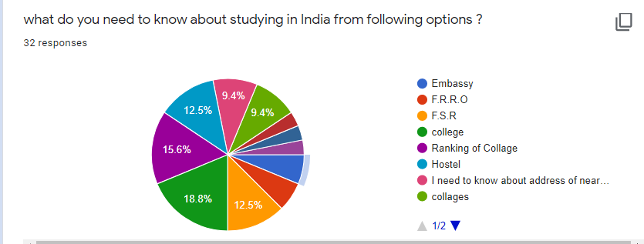

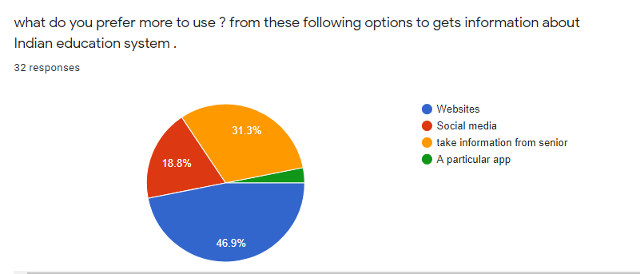

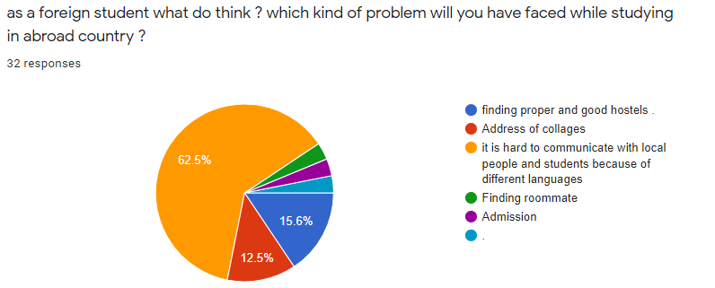

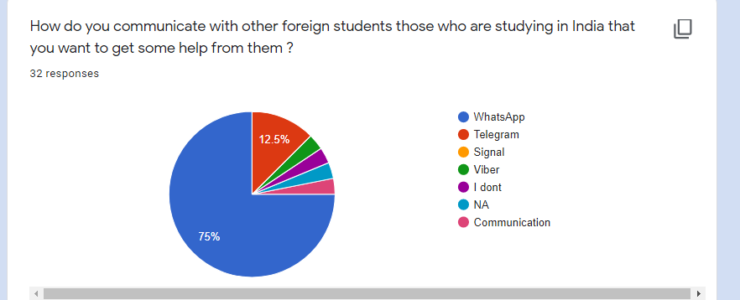

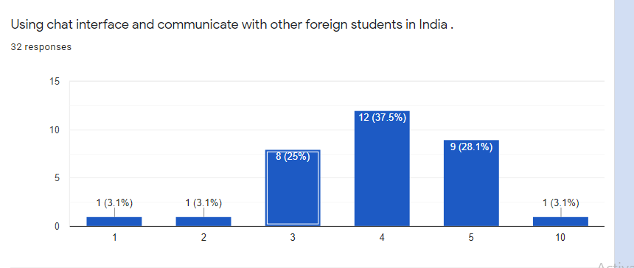

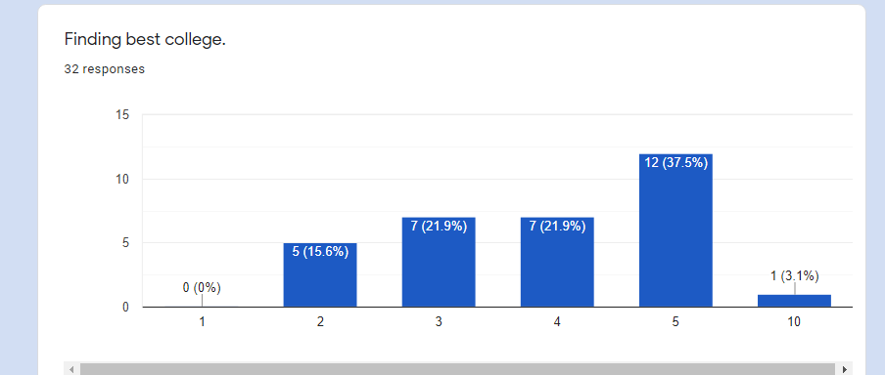

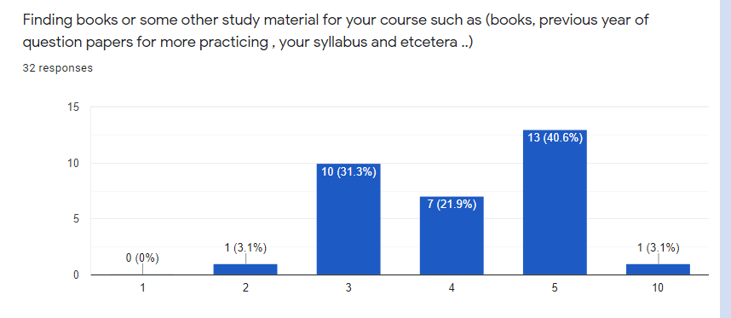

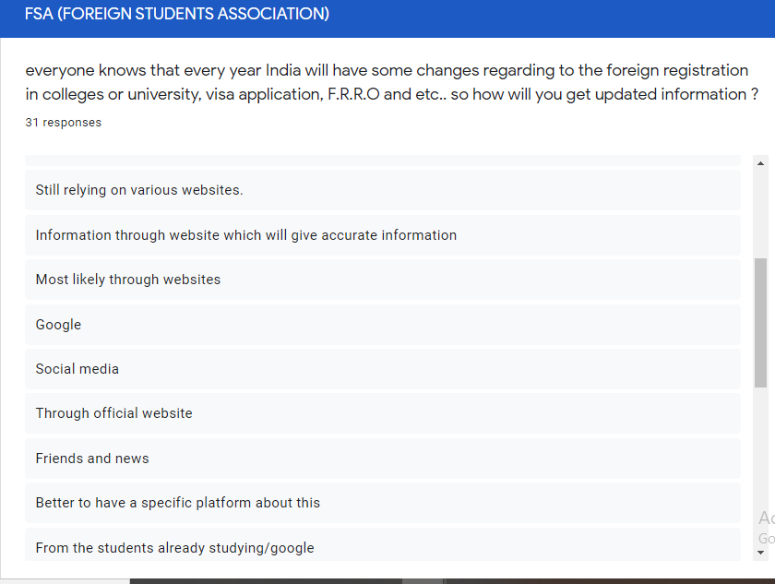

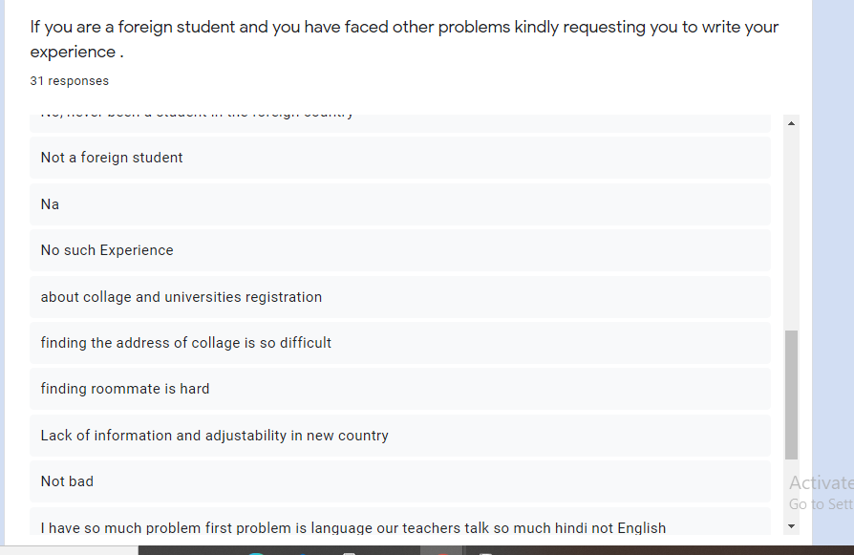

Chapter 2

1. Introduction

1.1 Purpose

The purpose of this document is to build an online system to provide the information about education system in India and for help foreign student to communicate with each other easily.

Including the revision or release number Describe the scope of the product that is covered by this SRS, particularly if this SRS describes only part of the system or a single subsystem.

**1.2 Document conventions**

The use of proper document convention is necessary for any project or report.

The SRS file should write properly such convention has been take consideration. Bold font .color and bullets for important point or facts.

Heading are used for the topic with well listed points.

Link for the different sites for reference or has been kept blue and underlined use for distinguish them easily.

**1.3 INTENDED AUDIENCE AND READING SUGGESTIONS**

* Student
* Admin

This project is for providing information about colleges and makes a system to communicate foreign students together and it is restricted within the college premises. This has been implemented under the guidance of college student. This project is useful for those foreign students whose want to start studying in India.

**1.4 PROJECT SCOPE**

* User can view the all Web pages
* User can upload information
* User can use chat interface
* Administrator can upload information and document
* Administrator can block the user

**Out of scope**

* User can’t create a group chat
* User can’t upload the document.
* The user can’t take admission from this website for university and take appointment in F.R.R.O.

**1.5 REFERENCES**

* 1. Link of GUI

<https://sites.google.com/s/1Vz-9-XNm-gAO9--JPUsMTpkyIDPKi_N1/edit?userId=114245511539439480945>

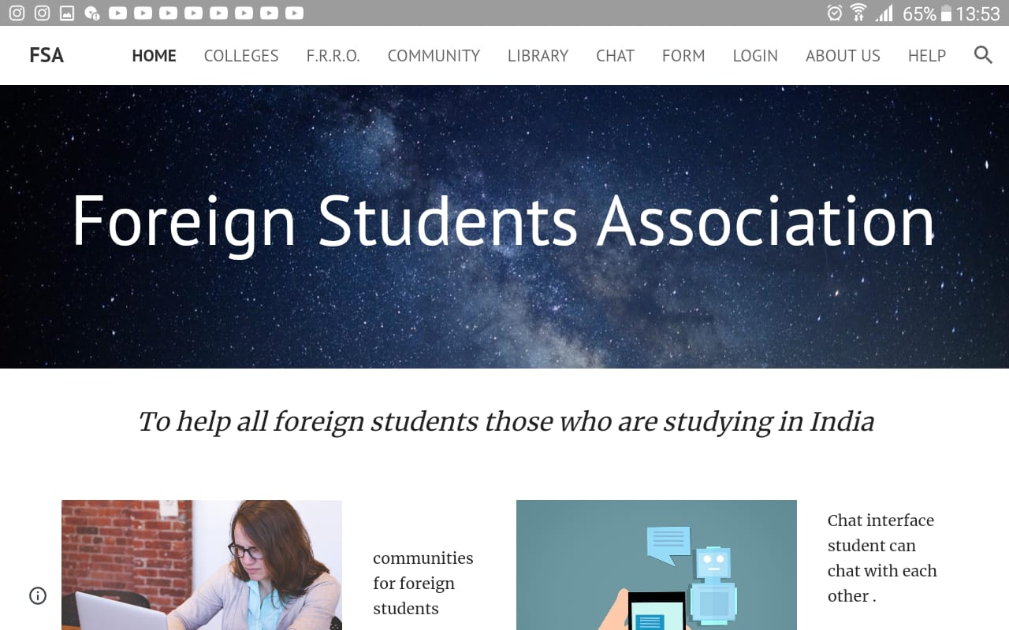

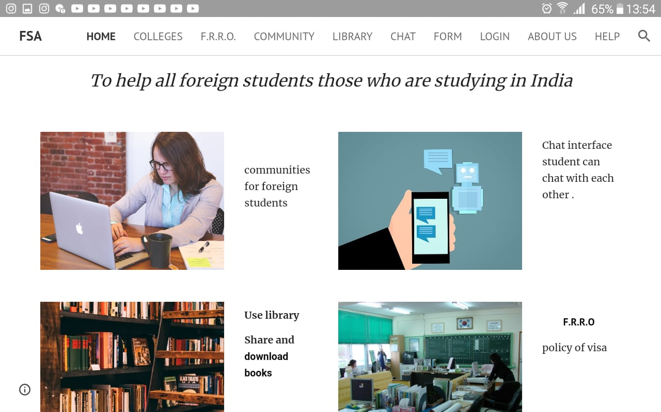

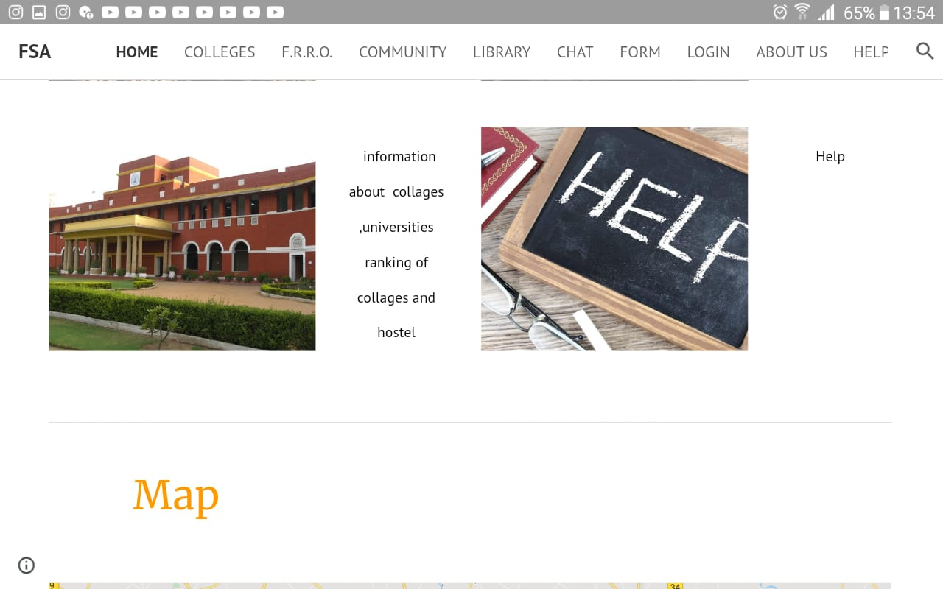



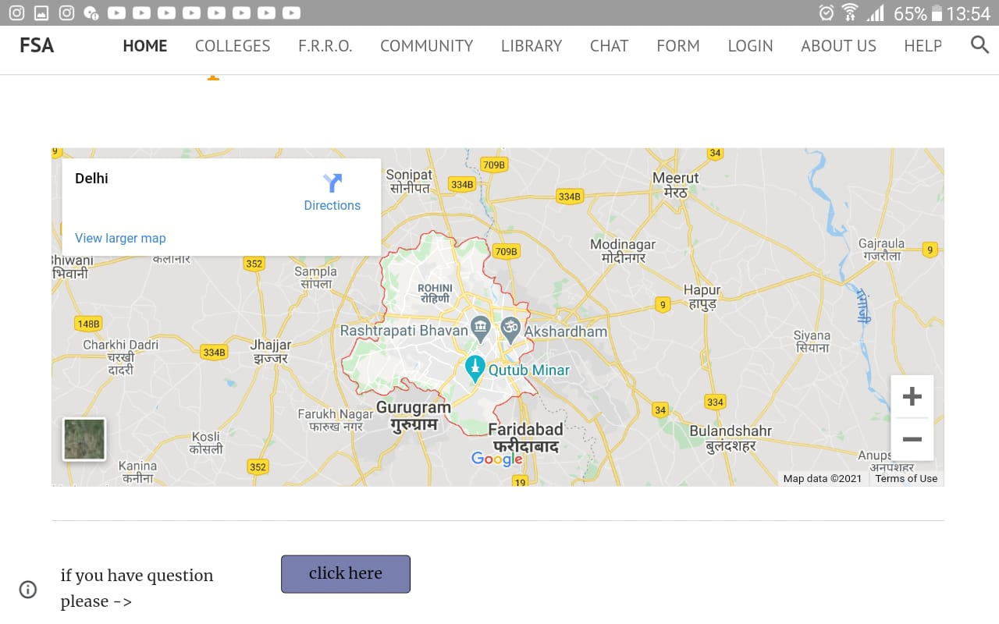

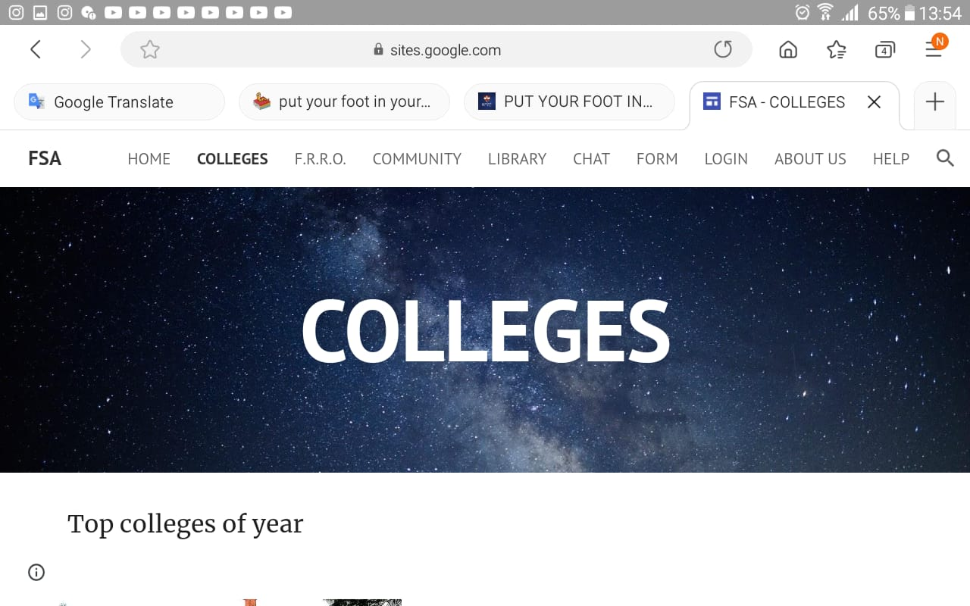

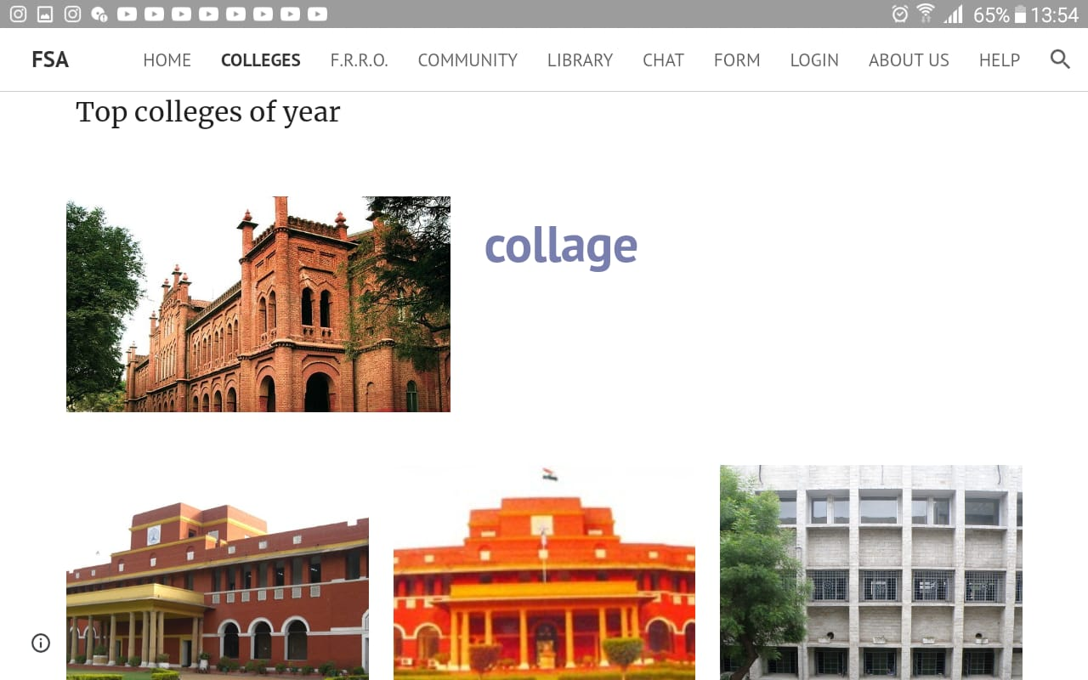



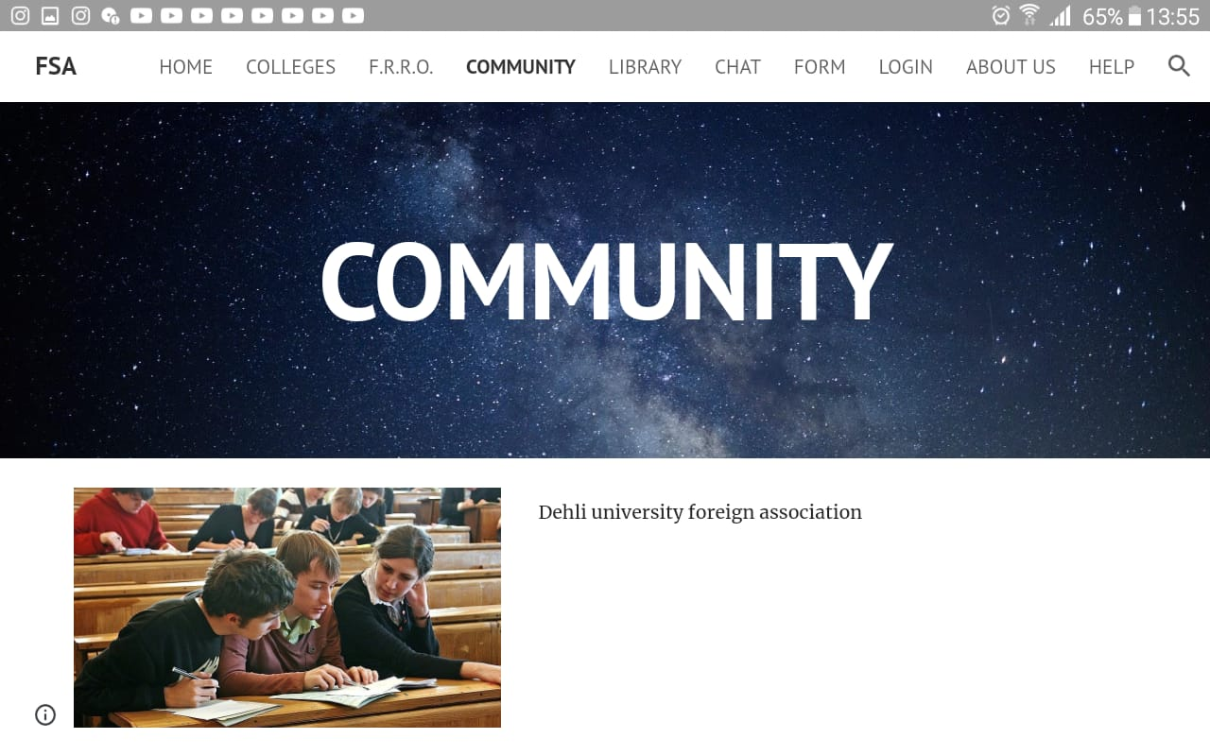

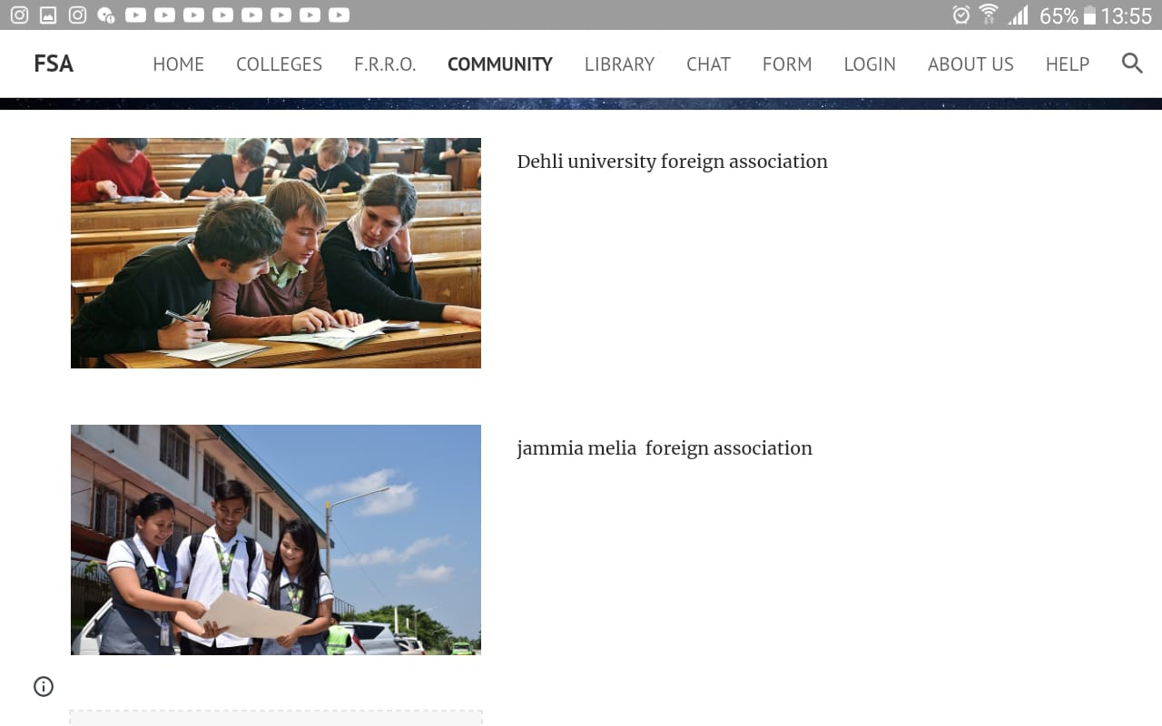

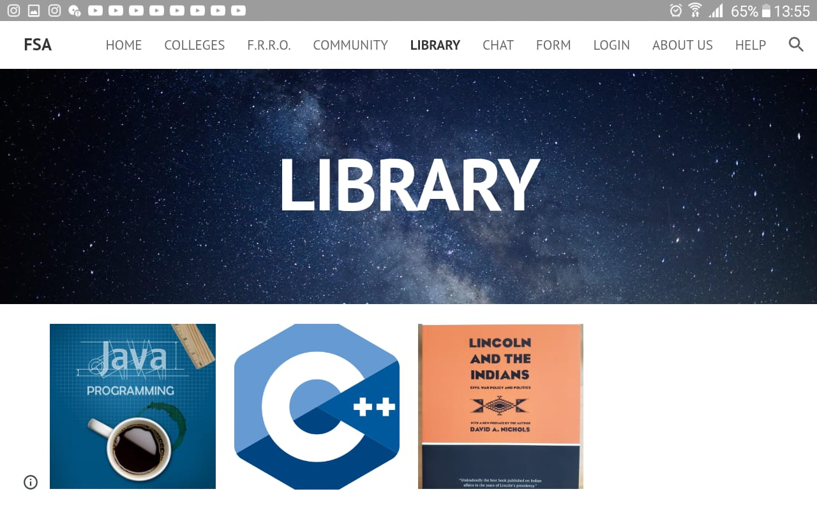

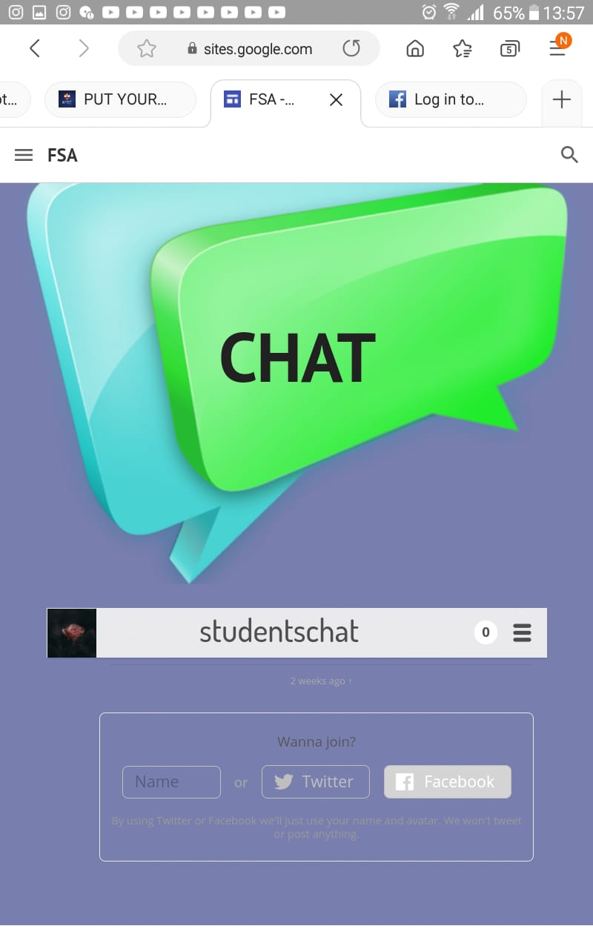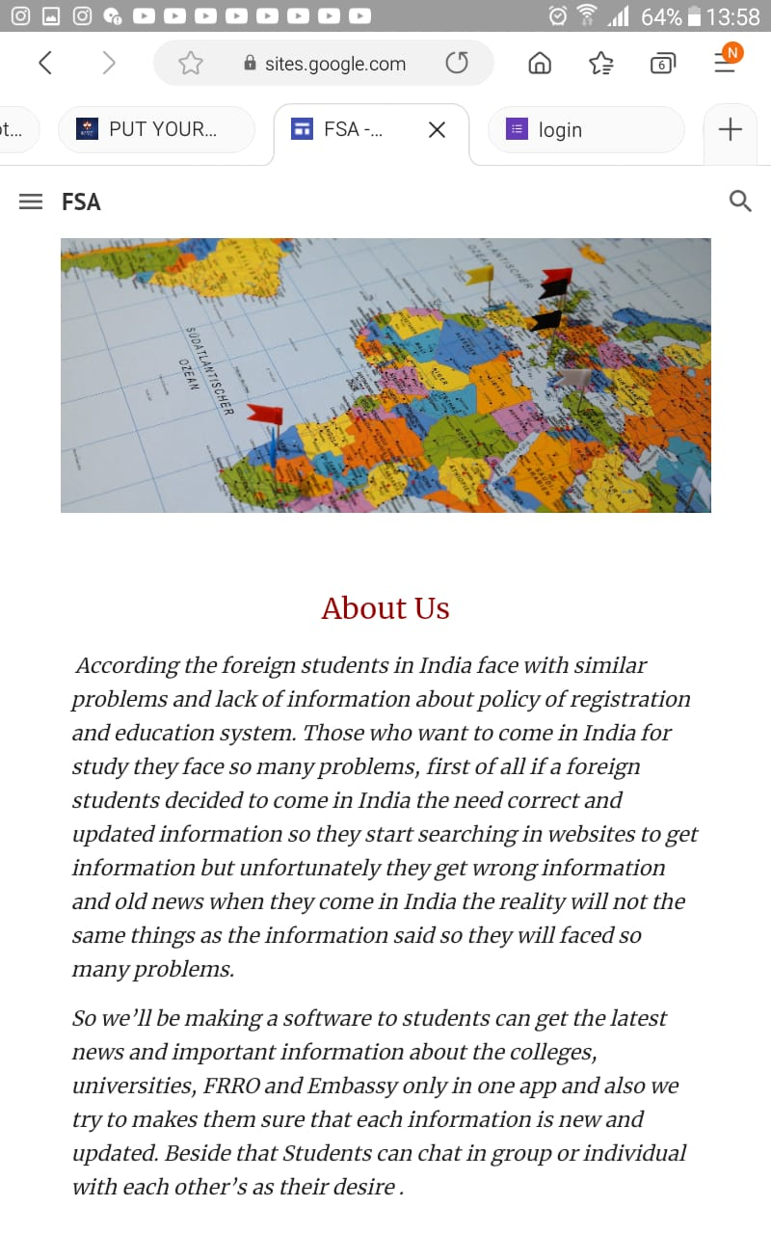

* 1. Link of Google from

<https://forms.gle/zqsStduHsrwuUnMF7>

2. Overall Description

2.1 product Perspective

This product or system is designed to provide the communication system for students and upload correct information for the foreign students.

The system helps the students to have communicates with each other easy. And system quick and easy to use .

2.2 product function of

Functionality of the system

* **Registration** - To access this system, it’s necessary for user to Registered at first
* **Log In -** The user will be able to use the system by logging with Email ID.
* **Chat interface -** The user will be able to use chat interface to Communicate with other students.
* **Downloads document -** User can read and download the

Excites document

* **Upload information -** The user and admin will be able to upload His/her own information
* **Update information - Administrator** will be able to update the Information and remove the old and incorrect information.

**2.3 User classes and Characteristic**

* The user will be and students and also for those student who want to start study in India.
* The user must know English language.
* The user should able know how to use smartphone or computer.

**2.4 operating Environment**

* The system will be operated with webserver smartphone and computer an active internet Connection.

2.5 Design and implementation Constraints

* The User must have proper browser to access the website.
* The processor used must be able to execute the browser.
* The system should be able to accommodate the variations like the chat interface, download and upload should be handle easily and fast.

2.6 User Documentation

The system will able the user to visit every page and download the document. The system will able user can’t use chat interface and upload information and common in information

The use have register with him/her email ID after that use can use the chat interface and upload information .The system will have very friendly GUI(Graphic User Interface) and registration

And use of the system will be easy and understandable .and the system will have the help option to guide the user ahead without and difficulty.

**2.7 Assumptions and Dependencies**

* The system will support all the current smartphone and browsers.
* The system will require an active internet connection**.**

**3. External Interface Requirements**

3.1 User Interfaces

The system will have friendly user interface and it will be easy to understand.

User will not require any prior specialization in handling software. It would require the basic knowledge of browsing , operating devices and English language.

Here are the must possible provide system

Link <https://sites.google.com/s/1Vz-9-XNm-gAO9--JPUsMTpkyIDPKi_N1/edit?userId=114245511539439480945>

3.2 Hardware Interfaces

* Internet connection.
* Smartphone or computer.

3.3 Software Interfaces

* The use need the browser that should be able to open the web pages

3.4 Communication Interface

The user will need to give his/her contact details like e-mail address while Sing up so that the account can be restored in case she/he forgets login details. Using the email ID they may also get notified about the important information and Function.

**4. Use Case**

Use case diagram

**Administrator**

**SEE ALL FACIESES**

**CHAT INTERFACE**

**SHARE INFORMATION**

**DONWNLOAD INFORMATION**

**LOGIN**

**USE LIBRARY**

**UPDATE INFORMATION**

**User**

**SHARE SOURCE**

Use Case Template (Login as Administrator)

Description:-Login in the system as Administrator.

Actor:-Administrator;

FLOW OF EVENTS

Basic flow

1. Enter ID and password
2. Logged into the system as Admin

Alternate flow

1. Wrong ID or password

Special requirement:-Working internet connection

Pre-condition:- pre-defined ID and password

Post-condition:- none

Use case template (share data & link)

Description:-Upload & Update the information and link

Actor:-Administrator

FLOW EVENTS

Basic flow

1. Provides the latest information and link that is necessary for foreign students

Alternate flow

1. The information already exist in the website

Special requirement: internet connection

Pre-condition: Must be logged in as administrator

Post-condition: the data successfully updated

Use case template: - (share source)

Description:-Share the source and document.

Actor:-Administrator

Basic of events

1. Provide the data

Alternate flow

1. None

Special Requirement: -None

Pre-condition:- The document must exist

Post-condition:- data should upload successfully

Use case template: (see all facieses)

Description: Students see all the facieses

Actor: students (user)

Flow of event

Basic flow

1. Choice the option

Alternate flow

1. None

Special requirement: - Internet connection

Pre-condition:-None

Post-condition:-None

Use case template (login as user (students))

Description: - log into the system as user

Actor:-user (students)

Flow of events

Basic flow

1. Email ID and password
2. logged into the system as user(student )

Alternate flow

1. Wrong Email ID or password

Special requirement:-They have to connection to internet

Pre-condition:-They should have email ID

Post-condition:-None

Use case template (share data & link)

Description: Upload & Update the information and link

Actor:-User

Flow events

Basic flow

1. Enter email ID
2. Enter password
3. Successfully login
4. Provides the latest information and link that necessary for foreign students

Alternate flow

1. None

Special requirement:-None

Pre-condition:-Must be logged in as user

Post-condition:-The data successfully updated

Use case template (download the data)

Description:-User can download the data

Actor:-User

Flow events

Basic flow

1. The data should be exist

Alternate flow

1. None

Special requirement:-data

Pre-condition:-None

Post-condition:-The data should download successfully

Use case template (use library)

Description: user visit library

Actor:-User

Flow events

Basic flow

1. The library should be exist
2. The data should exist in library
3. Browser should be able to open PDF

Alternate flow

1. None

Special requirement:-Data should be exist

Pre-condition:-None

Post-condition:-None

Use case template (chat interface)

Description:-User can chat with each other

Actor:-User

Flow events

Basic flow

1. Enter email ID
2. Enter password
3. Successfully login

Alternate flow

1. login details wrong
2. forgot password => System send OTP to registered email id
3. Resets password

Special requirement:-None

Pre-condition:-Must registered

Post-condition:-Can use the chat interface

**5. Other Nonfunctional Requirements**

5.1 Performance Requirement:

* **Time**: The elapsed time between the sending massage and receiving massage should minimum as possible.
* **User friendly:** The system should be user friendly / The GUI should be kept simple and uncluttered and easy to understand.
* **Flexibility:**  The system should be flexible to make further changes and when required in future.
* **Reusability:** All the user pages that are being used for user information should be easily to get processed so that we can interact as many user as possible easily and fast without consuming much times

5.2 Safety Requirement

If there is any damage, or harm to the database of the system resulting from the use of the system, the recovery method of the system will restore the past copy of the database that was backed up to the storage of the system.

5.3 SecurityRequirements

The system will be using the two factor authentication for the sake of security of user information and privacy.

5.4 Software Quality Attributes

* **Reliability:** The system should be reliable to the user to use.
* **Reusability:** All the user page that are being used for user information should be easily processed so that the system can deal with many user easily at a time.
* **Availability:** The system shall be available during the running hours.
* **Flexibility:** All the user web pages that are being used by user.
* **Maintainability:** It should be maintain in case if any bug is detected in future.
* **Usability:** The system interface should be self-explanatory and usable.

**5.5 Business Rules**

While using this system only admin will have the right updated user details, to verify the account of user of admin. The have the right to odd or remove them they can deny access to the user if he/she is found being suspicious.

Administrator will be able to manage their account and post the commercial of university and colleges.

The student will be able to manage their account they can view all facieses and download the document use chat interface to communicate with other students and take the correct information about anything without going to their and

Speed a lot money and time.

# 6. Other Requirements

<Define any other requirements not covered elsewhere in the SRS. This might include database requirements, internationalization requirements, legal requirements, reuse objectives for the project, and so on. Add any new sections that are pertinent to the project.>

Appendix A: Glossary

<Define all the terms necessary to properly interpret the SRS, including acronyms and abbreviations. You may wish to build a separate glossary that spans multiple projects or the entire organization, and just include terms specific to a single project in each SRS.>

Appendix B: Analysis Models

<Optionally, include any pertinent analysis models, such as data flow diagrams, class diagrams, state-transition diagrams, or entity-relationship diagrams.>

Appendix C: To Be Determined List

<Collect a numbered list of the TBD (to be determined) references that remain in the SRS so they can be tracked to closure.>

Chapter 3

3.1: Gantt chart

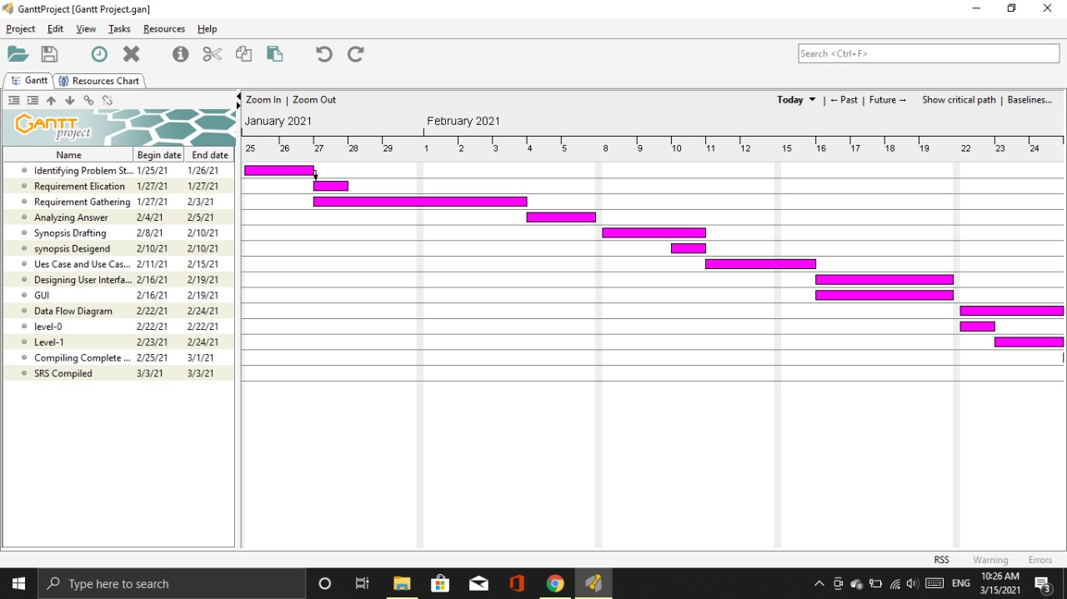

3.2: Risk Management and Analysis

|  |  |  |
| --- | --- | --- |
| **Risk** | **Effect** | level |
| Server gets hacked | Personal data of use can be lack | Catastrophic |
| Admin account gets hacked | The student cannot get the correct information and communicate with each other properly | Catastrophic |
| Storage not enough for all students | The student cant post the information any more | Critical |
| Issue of incorrect password | User will not able to access the same feature of website | Marginal |
| Testing reveals lot of defects | In the test time defect a lot of part of website | Marginal |
| Design is not robust | The website is not enough good as we expect | Marginal |
| Internet disconnected during registration | The account of user is not make completely | Marginal |
| business less | The website will be useless nobody going to use the website | Critical |
| Wrong user interface | The user interface is not enough friendly | Marginal |

3.3: Function Point Analysis

|  |  |  |  |
| --- | --- | --- | --- |
| **Users/Resource file** | **cases** | **Function unite** | **Complexity** |
| Students | Login | External input | High |
| Students | Add Notice image | External input | High |
| Students | Add comment | External input | High |
| Students | Upload Notice image | External input | Average |
| Students | Upload comment | External input | Average |
| Students | Deletes Notice image | External input | Low |
| Students | Deletes comment | External input | Low |
| Students | Add other in to | External input | low |
| Students | Upload other into | External input | Low |
| Students | View information | External output | high |
| Students | Use chat interface | Flow even | High |
| Students | Delete other into | External input | Low |
| Admin | Login | External input | High |
| Admin | Add Notice and Image | External input | high |
| Admin | Add comment | External input | High |
| Admin | Upload Notice image | External input | Average |
| Admin | Upload comment | External input | Average |
| Admin | delete Notice image | External input | Low |
| Admin | Delete comment | External input | Low |
| Admin | Delete student | External input | Low |
| Admin | View information | External output | High |
| Admin | Use chat interface | Flow event | High |

Chapter 4

**4.1:**  **Interface Design**

**4.2: ER Diagram**

USER Course

Has

USER _P

1 1

N

1 1

has

1

Admin

Have

1

1

have

Comment

Post

Have

Chat

Chat

Comment

Comment

have

Document post

N

1 N

!

N

**4.2.1:** **Database Schema**

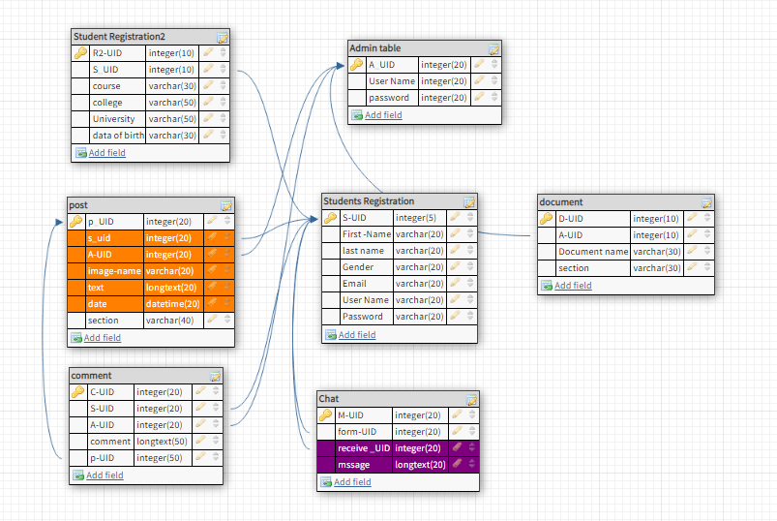

**4.3: Architectural Design**

**Architectural Design**

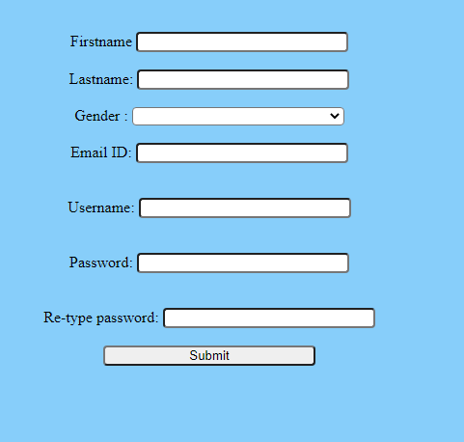

All information going to store in the database.

And verifies that the password and the confirmation password are the same or not?

If the password and confirmation password is the same, it will store in the database.

Otherwise, it will not store the password in the database.

And it will show an error message

"Password and confirmation password is not same".

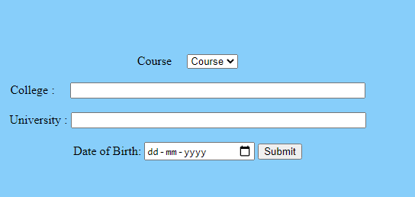

All data will store in the database.

Course selection: In this part, the user must be chosen those courses given by the website, all course is not available in this website.

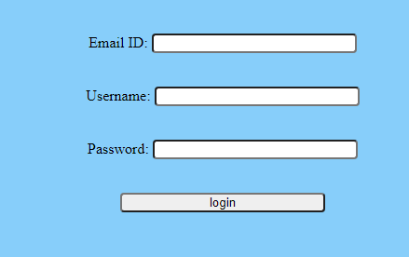

The entered data by a user must be matching with

Student personal information table in the database and attributes Email, Username, and Password must be same.

If the data matches his/she can log in into the system otherwise his/she returns to the login page automatically by the website.

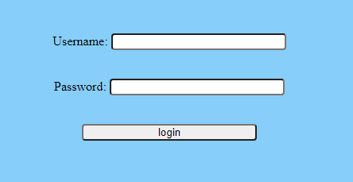

The entered data by the admin going must be matching with the admin table in the database and attributes Username and Password must be the same.

If the data matches he/she can log in to the system otherwise he/she returns to the login page automatically by the website. 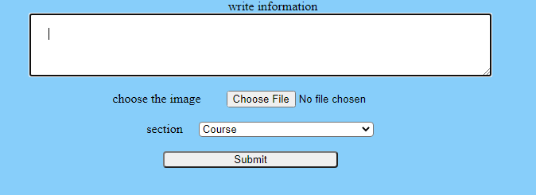

The user can post him /her article, information, and opinion

And they also can attach an image with that. They have to choose the selection of the then they can submit the post.

Name of student came from student personal table

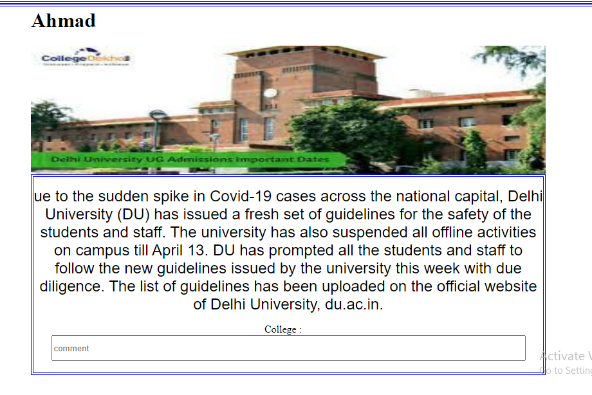

Photos and texts will come from the database post table and it will display according to the date of post & text and, It will be displayed the latest post by the date and update every day, and displayed on the first page of the website.

The comments are linked with the comment table and it will save and display all the comments of the post according to the PUID.

The posts will display on the Home page randomly it’s according the Latest date and most commented posts.

In the other option, the posts will display according to the latest date and sections (for example in the college option all posts will display by those posts that were posted in the college section).

**4.4: Implementation**

**https://drive.google.com/drive/folders/1M01VlmSs2aziDMIJsKGW-ramLWVIh8-t?usp=sharing**

Chapter 5

**5.1: Test Cases**

|  |  |  |  |  |  |  |  |  |  |  |  |
| --- | --- | --- | --- | --- | --- | --- | --- | --- | --- | --- | --- |
| Registration | |  |  | | --- | --- | | **Test condition** | Expected Result | | Check the Registration page is working. | The user should access the Registration page without any error. | | Enter more than 50 character in each  Fields. | The error message should display “Registration not accepted  More than 50 characters”. | | Leave some fields empty. | The error message should display  “Please fill the blank fields”. | | If Password and confirm password is not matching. | The error message should display “The password and confirm password not match”. | |
| Course  Registration(II) | |  |  | | --- | --- | | Course registration is available. | The Course Registration should open  Automatically after submitting the first registration page. | | Enter more than 50 character in each Fields. | The error message should display “Registration not accepted  More than 50 characters”. | | Enter the age above 50 year. | The registration is not accepted the error message should display “Your age is not acceptable”. | |
| Login | |  |  | | --- | --- | | Login page is working. | The user should access the login page without any error. | | Invalid username and valid password. | The login should be successful. | | The password is valid and the Username in invalid. | The error message should be displayed either Your Username or your Password is wrong. | | The valid username and the invalid password. | The error message should be display  Wrong password. Try again or click ‘forgot password ‘to reset it. | | Leave password fields empty. | The error message should display  Please enter your password then try again. | | The show and hide password | The show and hide password should act the correct behaviour. | |
| Post | |  |  | | --- | --- | | User is not login in the system. | The user will not be able to access the new post option. | | Fill all the fields correctly. | The message should be displayed. Your post is successful. Do you want to post more? | | The text fields are empty and the photo fields are filled. | The message should be displayed. Your post is successful. Do you want to post more? | | The section fields is empty. | The error message should display Please choose the section of your post. | | If the User chooses a file except for the image. | Your file is not acceptable please choose just the image. |  | |

**5.2: Flow Graph**

**5.3:** **Cycolmetric complexity**

<?php

$Username=$_POST['Username'];

$pass=$_POST['pass'];

$con=mysqli_connect('localhost','root');

mysqli_select_db($con,'FSA');

$q="select * from Admin where&& aname='$Username'&& aPASSWORD='$pass' ";

$result=mysqli_query($con,$q);

$num=mysql_num_rows($result);

if($num==1)

{

$_SESSION['Username']=$Username;

Header[profile.php]

}

else

{

header[login.htlm]

}

mysqli_close($con);

?>

References – Srs template, online site w3school   
Annexure –

Coding

https://drive.google.com/drive/folders/1M01VlmSs2aziDMIJsKGW-ramLWVIh8-t?usp=sharing

Google Form Responses

https://docs.google.com/spreadsheets/d/1Z3xp41SNG0-rIlMQUGW89XYx7yYpZf40Bd-Vz3xXDU8/edit?usp=drivesdk

GUI

<https://sites.google.com/s/1Vz-9-XNm-gAO9-->JPUsMTpkyIDPKi_N1/edit?userId=114245511539439480945